**Sudeep KT – Day1**

**Infra CI/CD Pipelines - Overview of GitLab Private Runner**

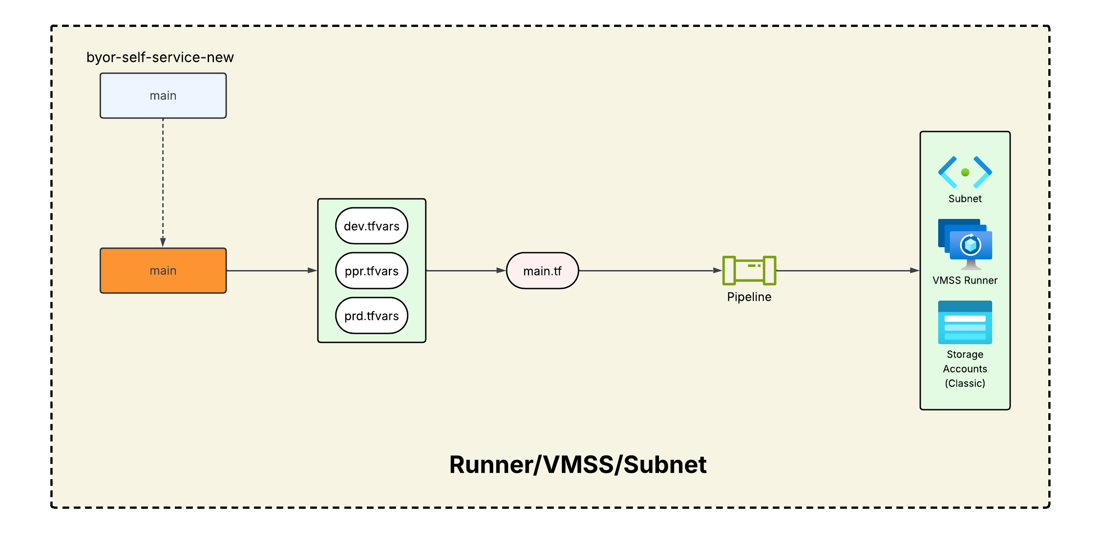

**Our Repo link:** <https://gitlab.dx1.lseg.com/app/app-51518/developer-portal-infra/byor-self-service-new>

**Main Repo Link:** <https://gitlab.dx1.lseg.com/ci/stable/gitlab-runners/lmp-gitlab-runners/byor-self-service>

**Doc link :** <https://gitlab.dx1.lseg.com/app/app-51518/developer-portal-infra/byor-self-service-new/-/blob/main/README.md?ref_type=heads>

**Jira Ticket :** <https://jira.refinitiv.com/browse/DEVP-2123?workflowName=DEVP%3A+Task+Simplified+Workflow&stepId=23>

**Lucidchart:** <https://lucid.app/lucidchart/fd75974b-ab6c-457c-a301-9c061505c568/edit?invitationId=inv_c285070d-81b6-4ee6-b134-ed05948b80a6&page=upSP7svwYBAT#>

**Sudeep KT – Day 2**